

My Target: /25 or %

**Unit 1 Modern History**

**Score:**

/25

***Understanding the Modern World***

***SOURCE ANALYSIS ONE***

**THE AGE OF IMPERIALISM 1848 - 1914**

[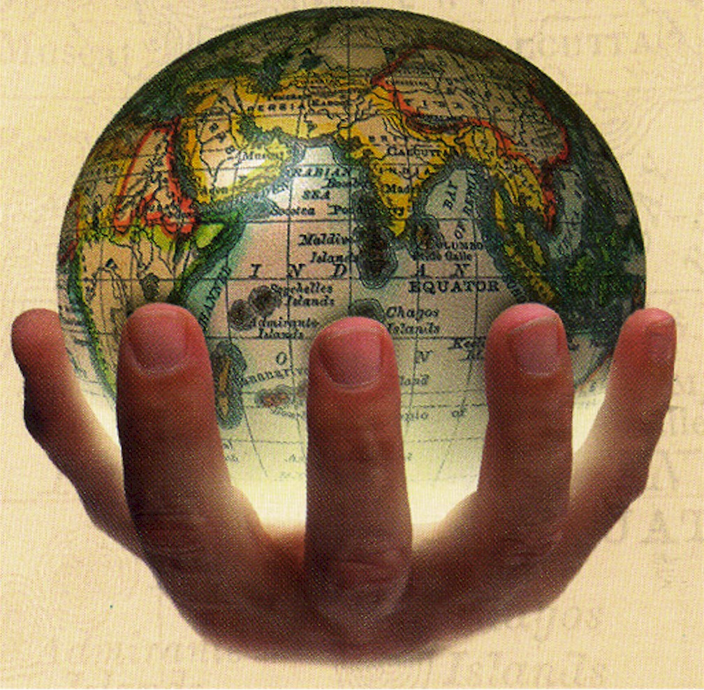](http://www.google.com.au/url?sa=i&rct=j&q=&esrc=s&frm=1&source=images&cd=&cad=rja&uact=8&ved=0CAcQjRw&url=http://www.slideshare.net/wendyji/chapter-24-pba-imperialism-childrens-book&ei=ZclKVa6rEomAU8jGgJgD&bvm=bv.92765956,d.d24&psig=AFQjCNFfLZl-gipFk2mLRzYkGshgViehtQ&ust=1431050969259287)

*Name: _______________________ Date:*

**Weighting - 10 %**

**Question 1**

Compare and contrast the messages in **Source 1** and **2**. *(4 marks)*

*(****HINT****: Identify the message of each source first - what the author is trying to get you to think, or feel, or understand. Then discuss the similarities between each message – what do they share that are the same. Then discuss the differences between each message – are they from different perspectives/from different era’s (how might that effect the message given?/ related to differing topics etc.):*

**Question 2**

**Evaluate** the usefulnessof **Source 1** and **2** as representations of colonialism during the period of study.

*(5 marks)*

*(****HINT****:* *Examine the source/sources and ‘weigh up’ and make a judgment on how well the source/sources show (cohesion & division/ international tensions & rivalries). Do they; represent all aspects of those key ideas?, Omit some of the key ideas? Or Only present a certain viewpoint – one sided? Specifically state ‘how’ useful the source/sources are)*

**Question 3**

**Explain** the historical context of **Source 1**. *(4 marks)*

*(****HINT****: Which event/idea within your period of study does this source belong? Identify what, when, where, who. Then briefly explain the factors that made this occur – what were the causes? Then briefly explain what happened as a result of this event/idea – what were the effects?):*

**Question 4**

Identify and account for the authors’ perspectives in **Sources 3** and **4**, regarding political views within your period of study. *(6 marks)*

(***HINT:*** *Examine the sources and point out what the authors’ viewpoint is. Explain why the authors would have this viewpoint. What political view is being shown? Who is the author is for each source and what would make them take this viewpoint? What is the date the sources were published? How might this have affected the authors’ decisions to view things in the way – what was happening at that time to influence the author? Who do you believe was the intended audience?)*

**Question 5**

Evaluate the extent to which the **four** sources give an accurate insight into the Age of the Imperialism. *(6 marks)*

*(****HINT:*** Are each of the sources accurate representations of the period of study? Has any Bias been used that makes a source an inaccurate representation of the period of study? Are any of the sources particularly more useful than others in helping you gain an understanding of the period of study?)

Spare Paper:

**END OF QUESTION BOOKLET**

**Sources**

**Source 1:**

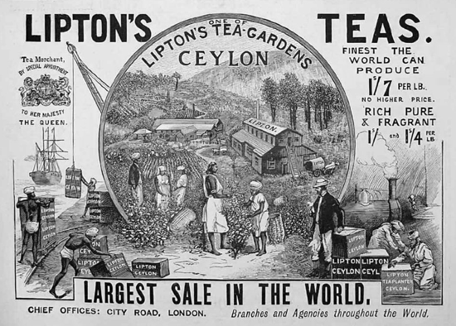

**Source 2:**

*British brains, British enterprise, and British capital have changed the face of India. Means of communication have been developed. There are great numbers of bridges, more than 40,000 miles of railway, and 70,000 miles of paved roads. These testify to the skill and industry of British engineers. Irrigation works on a very large scale have brought 30 million acres under cultivation. This has greatly added to the agricultural wealth of the country. Industrialization has also begun. India now has improved sanitation and a higher standard of living. It has a fine transport system and carefully thought-out schemes for relief work. Because of these things famines have now almost disappeared.*

Source: J.A.R. Marriott, *The English in India*, Clarendon Press, 1902

**Source 3:**

“The Empire was nearly destroyed by the great rebellion of 1857, described inaccurately as the Mutiny. The result of complex and multiple causes, the rising expressed the accumulated anger of many sections of the population in north and central India – dispossessed princes, disgruntled soldiers, and a harassed peasantry from whom the company’s army was largely recruited. The rebels committed acts of great brutality and were suppressed in equally brutal ways. The British in India bayed for even more bloody revenge. The rebellion created a legacy of racial hatred which permeated all aspects of the relationship between the ruler and the ruled”.

An excerpt by Tapan Raychauduri which appeared in “The Cambridge Illustrated History of the British Empire” (1996).

**Source 4**:

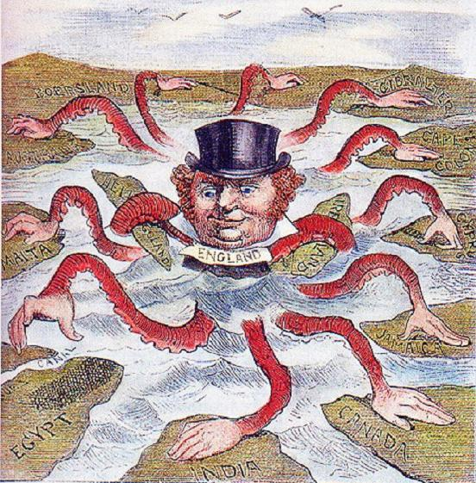

The “Devilfish in Egyptian waters” an anonymous American cartoon that was published in 1882.